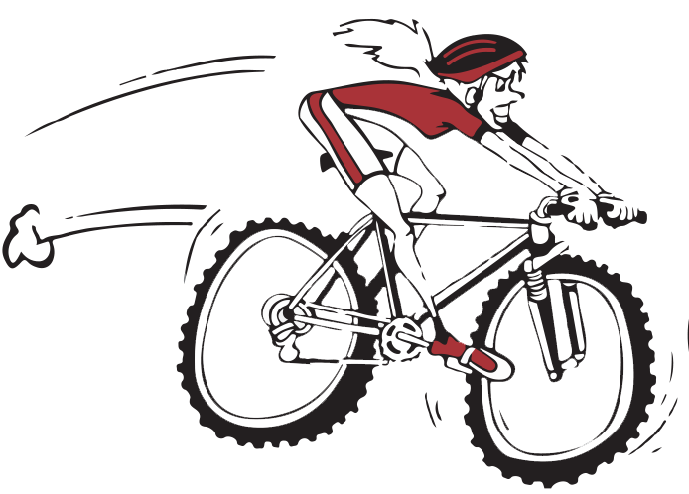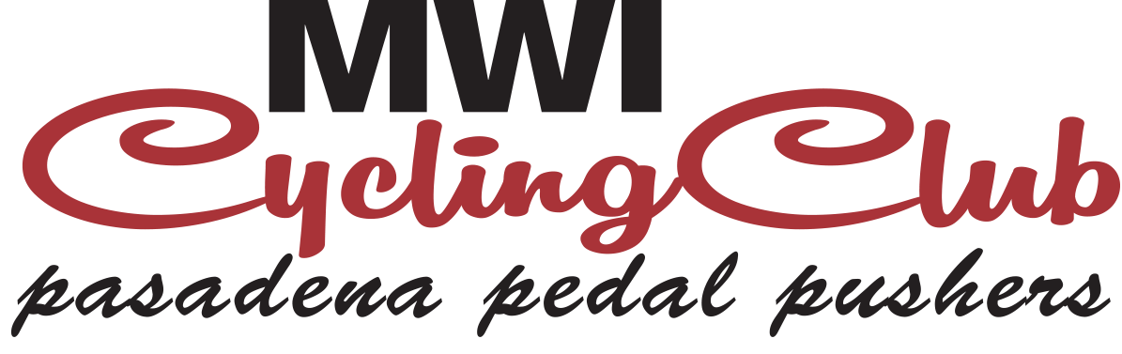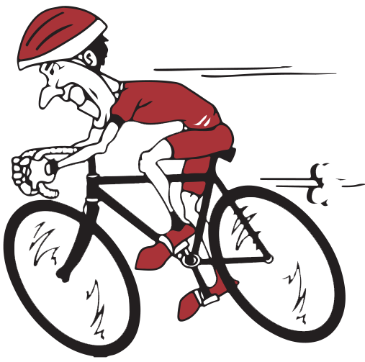
2015 Event Sponsor Form
Please make check out to: MWI Cycling Club, Inc.
Mail to: 1971 W. Feltson Ave. ATT: Robyn Knoelk Kuna, ID 83634

2nd Annual Charity Cycling Event September 12th 2015
The Idaho Poker Ride Pedal for Paws & Claws
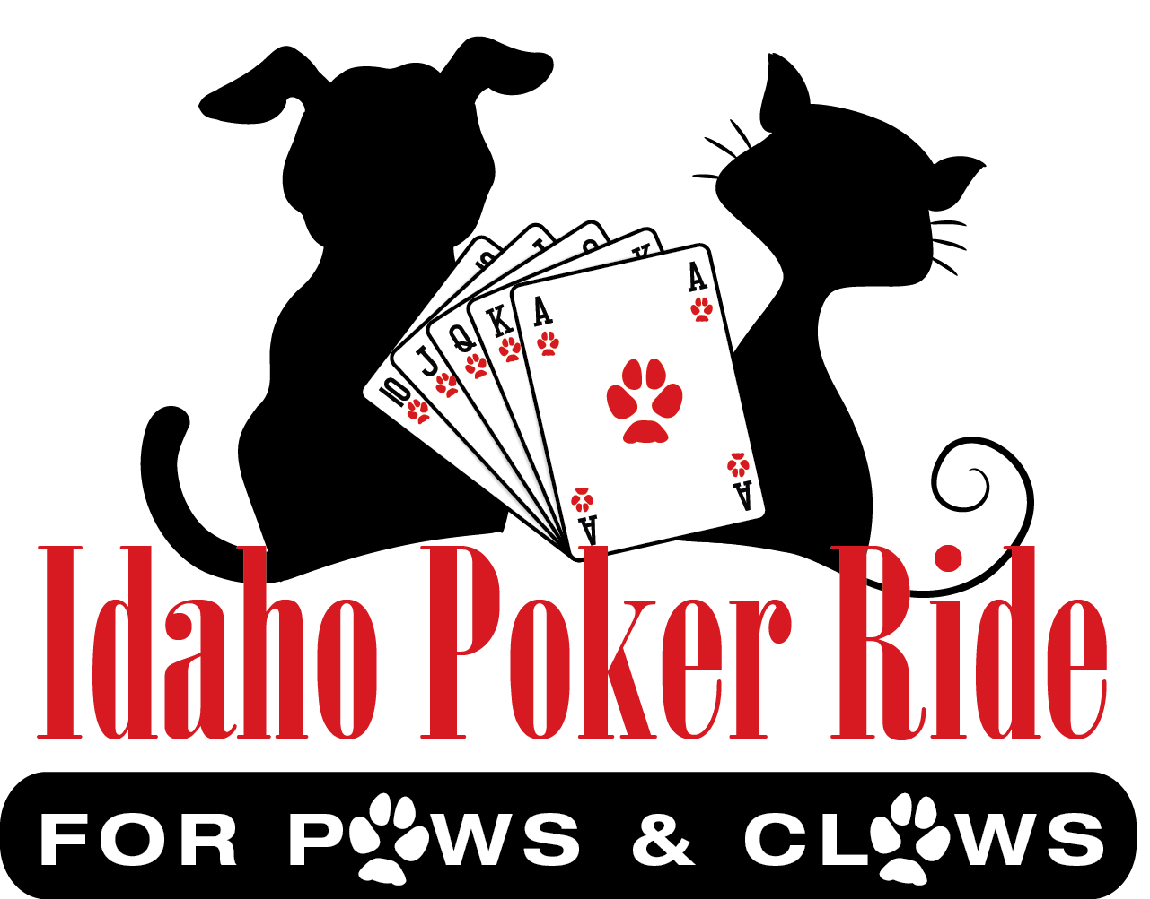
Benefiting 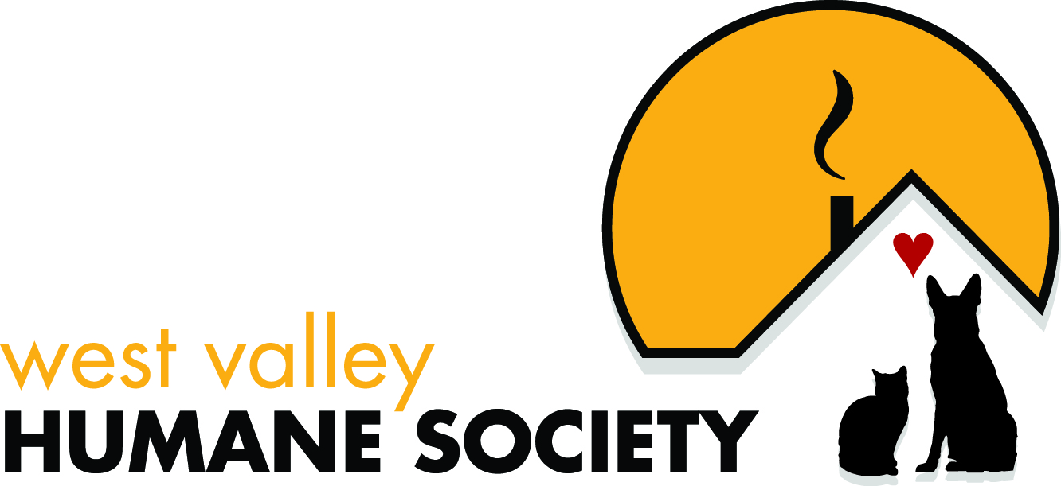
Sponsor Name: _________________ Address: ___________________
Phone #:_________ Credit Card #:________________ EXP Date:_____________

Husky Platinum Title Sponsorship Husky: $ 10,000.00
(Logo on Jerseys, T-Shirts, all Banners, Website, Booth, Media Mentions, Newsletter Advertising, 5 Rider Spots, 5 Goody Bags)
100 Mile Century Ride Title Sponsor $ 8,500.00
(Logo on Jerseys, Century Road signs, Vendor Booth, Website, Newsletter Advertising, 4 Goody Bags, 4 Rider Spots)

Rottweiler Gold Sponsorship Rottweiler: $5,500.00
(Logo on Jerseys, all Banners, Website, Media Mentions, Newsletter Advertising, 3 Rider Spots, 3 Goody Bags)

Maine Coon Silver Sponsorship Maine Coon: $1,500.00
(Website, Home Base Banners, 2 Rider Spots, 2 Goody Bags)

Ragdoll Bronze Sponsorship Ragdoll: $1,000.00
(Website, Home Base Banners, 1 Rider Spots, 1 Goody Bag)

Level 1 Puppy Sponsorship: $500.00 Level 2 Kitten Sponsorship: $375.00
(Website, 2 Goody Bags) (Website, 1 Goody Bag)

In-Kind Donation of your own choosing $__________

Prize Donations Needed

Name of Sponsor: __________________ Address: ______________________
Phone #:________________________ Email: ______________________
Items Needed for Prizes, Drawings and Silent Auction
Any new item of your choice is greatly appreciated. Below is a list of suggestions only.
iPod Nano’s, iPads, iPod’s Coffee Cards Discount Coupons
Gift Cards of any kind Gas Cards Sport Bars
Cycle Clothing Hats Patch Kits
Bike Meters Tire Pumps Tubes
Water Bottles Lights Helmets
Bottle Cages Bikes Service at Ride
Prizes are needed for three prizes in each ride choice. 15, 30, 63, & 100 mile rides. We also need at least 25-30 items for raffle drawings. Any extra prizes donated will be put up for silent auction. All the proceeds will go to West Valley Humane Society.
Thank you for your consideration in sponsoring and/ or donating for our 2nd annual event to be held September 12th 2015. Our event in 2014 Raised $10,500.00 for our shelters!! We anticipate that amount to double in 2015!
Volunteer to help on the day of the event! Volunteers will all get a goody bag with a T-shirt, lunch and some swag!
Any questions please do not hesitate to contact me. We look forward to your support for this exciting event!
Robyn Knoelk
Robyn Knoelk
Founder/President MWI Cycling Club
Executive Director Pedal for Paws & Claws
208-871-0951 / rknoelk@mwivet.com
www.mwicyclingclub.com www.pedalforpawsandclaws.org

